If you’ve ever found yourself in a situation where you have to tell your boss or a client some bad news, then you’ll know just how important it is to be able to use diplomatic English.
Choosing the right words and the right grammar can go a long way to removing some of the unpleasantness of the message we have to deliver. It can also help us to maintain a level of deference that we wish to show to superiors or clients in the normal course of business.
Using language diplomatically can be a challenge, even when speaking our mother tongue, but it is especially difficult when speaking a foreign language since we often lack the appropriate vocabulary, and a knowledge of alternative grammatical structures.
Consider the following sentence:
- I haven’t finished the report.
The speaker has done nothing here to soften the negative content of the message. A more diplomatic version might look something like this:
- I’m afraid I haven’t finished the report.
1. Softeners
‘I’m afraid’ is commonly referred to as a ‘softener’, a linguistic tool used to soften the tone of our content or convey politeness when we speak. Softeners often occur at the beginning of a sentence to prepare us for bad news: I’m afraid, so sorry, to be honest, unfortunately, with all respect
- To be honest, I think we need to rethink our marketing strategy.
- With all respect, I don’t agree with what you just said.
Read more:
Formal and Informal Email Phrases Starting with Greetings
2. Modal Verbs
Modal verbs such as would, could, may or might are great for softening a request or giving a command:
- I want more time to finish this presentation.
- I could use more time to finish this presentation.
- It would be nice to have more time to finish this presentation.
- Hand me the telephone, please.
- Would you hand me the telephone, please?
- Could you hand me the telephone, please?
3. Rephrasing a Negative Sentence
Negative sentences can be rephrased in order to make them appear more positive. Our very first sentence can be made even more diplomatic in this way:
- I’m afraid I haven’t finished the report.
- I’m afraid I haven’t been able to finish the report yet.
Using ‘be able to’ here places emphasis on your attempt to finish the report rather than your failure to do so. It implies that you are still working to complete the task and that your inability to do so is perhaps due to circumstances beyond your control (such as a heavy workload etc.).
The addition of ‘yet’ at the end of the sentence reinforces the idea that you are still working on the report and it is almost completed, thus helping to reduce the negative impact of the sentence’s underlying content.
Negative sentences that are formed with can’t and won’t make the speaker sound particularly negative and unhelpful and can often be rephrased with be able to, or a similar expression:
- I can’t give you a better deal than that.
- I am not able to give you a better deal than that.
- I am unable to give you a better deal than that.
- I am not in a position to give you a better deal than that.
Similarly, affirmative sentences containing words with a negative meaning can be rephrased in order to soften the message and achieve a more indirect effect:
- I am unhappy with this agreement.
- I am not entirely happy with this agreement.
- I am not totally happy with this agreement.
Here the negative adjective unhappy is replaced with its positive counterpart happy, modified with an adverb such as entirely, totally or completely, and the sentence is changed to the negative form.
Of course, to achieve the best results we’ll need to combine these techniques to make sentences that contain several of these elements:
- I’m afraid I haven’t been able to finish the report yet, so I’m not in a position to send it to you right now. Could you give me a little more time, please?
Hopefully, when you put some of these practical tips to use, you’ll find that being diplomatic and polite with colleagues or clients in English is not as difficult as it seems. To see more examples and the second part of this post go to
“Polite Expressions in English: Words, Phrases and Questions to be Kind”.
Read more:
Difference between POLITENESS and RESPECT
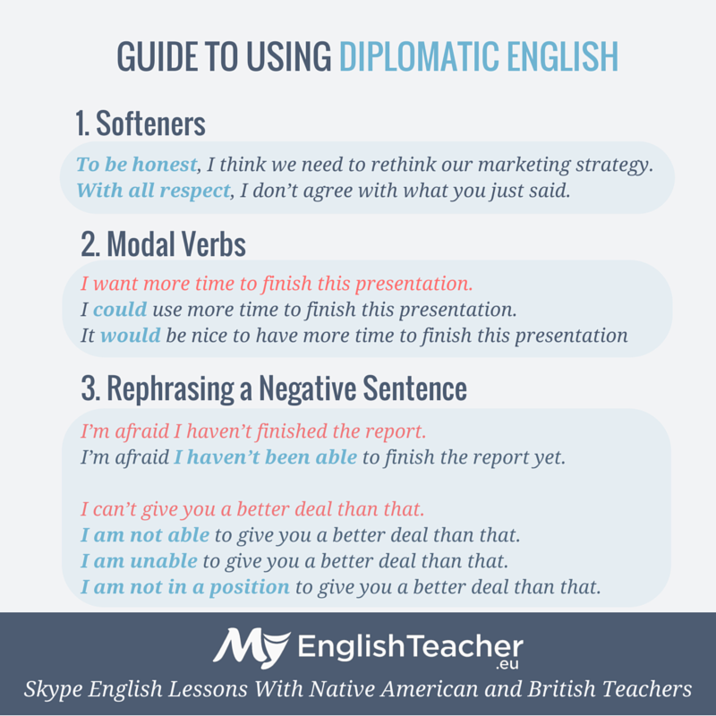
- Facebook
- Twitter
- Pinterest

- Facebook
- Twitter
- Pinterest
About author:
Jeremy Bentley is a professional native English teacher and a Greek to English translator. You can meet him and learn with him here at MyEnglishTeacher.eu.

ONE-TO-ONE SKYPE LESSONS WITH AN AMERICAN OR BRITISH ENGLISH TEACHER
Other schools teach you grammar rules
MyEnglishTeacher.eu helps you to become a confident English speaker
Let's get started

Written by: Anastasia Koltai

Founder of MyEnglishTeacher.eu. Ana is a fan of giving away free and useful materials both for English learners and teachers. In her free time she loves biking and playing with her dog.
Home » Language Talk » Language Tips »

5 Tips for Polite and Diplomatic Language
In this section
- Phonetic alphabet
- Why teach idioms?
- Prepositions
- Using Natural English
- 5 Tips for Polite and Diplomatic Language
- Despite the fact that...
- Understanding Newspaper Language
- Sporting Idioms
- Signs and symbols
- Comma (,)
Click here to listen to this podcast
In this podcast I'm going to teach you 5 ways to be polite and diplomatic in your speaking.
If you're too direct when you speak you can come across as aggressive and this might put people off. This is true in business meetings and negotiations, but also in many other day to day situations. Here are 5 ways you can make your English more polite, indirect and diplomatic. Follow these tips and you should make the right impression when you talk to people.
1. Listen and be understanding
If you show other people that you are listening to them, and that you understand them, they will be more willing to listen to you and accept your opinion. Don't just say "I disagree", show them that you are listening and that you understand them before you explain your opinion.
You can do this by using statements like:
Yes, but...
I see what you mean, but...
I agree up to a point, but
For example:
I think we should wait until a better opportunity comes along.
Yes, but we might not get another opportunity like this for a while.
I think we should ask for a 20% discount because it will show them that we are serious.
I see what you mean, but I think 20% might be a bit too much. It might put them off.
2. Avoid negative words - instead use positive words in a negative form
People react to positive sounding words, even if they are used with a negative auxiliary.
Don't say: I think that's a bad idea.
Say: I don't think that's such a good idea.
Let's go for a good cop, bad cop approach in this negotiation!
I don't think that's such a good idea. They might see through it.
3. Say the magic word: Sorry
This word can be used in many ways: to interrupt, to apologise, to show you don't understand, to disagree. It diffuses tension and it allows you to start a statement more comfortably.
Sorry, but can I just say something here
Sorry, but I don't really agree
Sorry, but I think that's out of the question
4. Use little words to soften your statements
Break down negative sentences with some softeners.
Don't say: I don't like it
Say: I don't really like it I'm afraid
Don't say: Can I say something?
Say: Can I just say something here?
Don't say: I didn't catch that
Say: Sorry, I didn't quite catch that
5. Avoid 'finger pointing' statements with the word 'you'
This is aggressive and too direct. Try to avoid saying 'you' and put the focus on 'I' or 'we'.
Don't say: You don't understand me.
Say: Perhaps I'm not making myself clear.
Don't say:You didn't explain this point.
Say: I didn't understand this point.
Don't say: You need to give us a better price.
Say: We're looking for a better price.
So, those are my 5 pieces of advice for being polite and diplomatic. Try to use them when you speaking and you will become a more effective communicator in English.

