In an earlier article I wrote about how to talk using casual language and formal language in English. I defined the words “casual” and “formal” before discussing the topic, and gave some practical examples of words and phrases, what they mean, and when to say them. This is a brief review in case you missed it:
Ca·su·al/ˈkaZHo͞oəl/adj designed for informal use; relaxed and unconcerned; casual words are widely used with people you know and are more comfortable being with
For·mal/ˈfôrməl/adj based on conventional forms and rules; formal words are suitable for important situations or occasions.
*****
Don’t forget to read part I of ‘2 Ways to Talk Casual and Formal in English‘ and part III ‘Casual Conversation in ESL – The Inside Scoop Part III‘

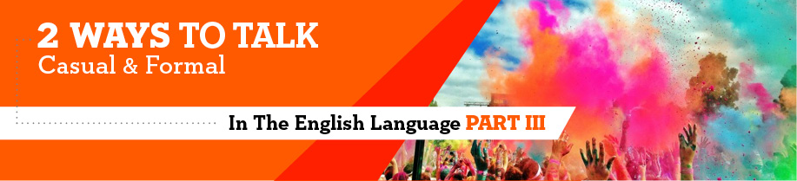
*****
Looking Closer at 2 Ways to Talk English
You should check out the article cuz (because) you all (all of you) might think it’s sick (great/amazing) to actually know the difference between the two ways to speak English. I gotta (have to) agree that it sucks (is terrible) when you don’t know exactly what to say, when to say it, or who to say it to… I dunno (don’t know) all of your reasons to learn English or not to learn it, but I am hoping that this article helps.
1. Ways to say “goodbye”

Formal
Goodbye – Goodbye, Mr. Jones. I enjoyed the conference.
Farewell – Margaret, farewell for now. I hope to call you for another business meeting soon.
It was a pleasure meeting you. – It was a pleasure meeting you, Ms. Smith. It would be a wonderful experience to work at your company. Thank you for taking the time to interview me today.
***
Informal
Take care – Take care. Maybe we can go to that movie this weekend.
Bye – Bye, Tommy. I’ll be in class tomorrow.
See you later – Mary, see you later around 8:00 for the dance.
Okay – Okay. Bye.
Have a good one – Mark, have a good one. I’ll try to watch your soccer game next week.
Bye, bye – Sal, bye, bye for now.
Later – Later, guys.
Talk to you later – Laura, talk to you later. Have to go to bed now… it’s been a long day.
So long – So long now, mom. I’ll call you in the morning.
All right then – All right then, John. That sounds like a good plan.
Catch you later – Diane, catch you later when I have more time.
Peace – Kirstin, peace now.
I’m out – Wow, I didn’t know it was this late. I’m out.
I’m outta here – Hey, I’m outta here. See you tomorrow.
Take it easy – Take it easy now.
Keep in touch – Yes, I’ll keep in touch.
We’ll keep in touch – Don’t worry. We’ll keep in touch. That’s for sure.
We gotta’ keep in touch – I agree. We gotta’ keep in touch.
Let’s call it a day – I have to get up early. Let’s call it a day.
Let’s call it an evening – I have an early meeting in the morning. Let’s call it an evening.
I should get going – I should get going. The babysitter is expecting me.
It’s getting late – It’s getting late. I promised to pick up dinner.
I’d better be going – I’d better be going. I have lots of errands to run.
Sorry, have to leave now – Sorry, have to leave now. We’ll make it longer next time.
See you around – See you around. It was fun.
It was nice to see you – I had a great time. It was nice to see you, Matthew
Hope to see you again – I really liked going to the concert with you. Hope to see you again.
Say hi to __ from me – Okay, bye. Say hi to ___ from me.
Have a good day – Have a good day now, Mark.
Have a nice day – Jimmy, have a nice day. Okay?
Have a good night – Heidi and Margot, have a good night. Have to run.
Have a nice night – Have a nice night. See you soon.
Have a good evening – Have a good evening. Got to run.
Have a nice evening – Have a nice evening. We’ll get together soon.
***
Foreign language good-byes are used informally
Adios or adios, amigos – Spanish. Adios, amigos. See you at the meeting.
Ciao – Italian. Ciao. Thanks again for your help.
Au revoir – French. Au revoir. I have to leave.
2. Ways to say “hello”
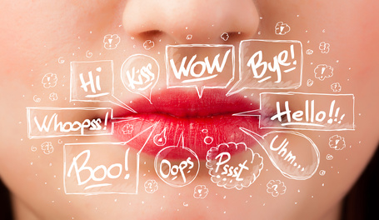
Formal
Hello – Hello, you must be the bank manager. It’s a pleasure to meet you.
Good morning – Good morning. Yes, I would love a cup of coffee.
Good afternoon – Good afternoon, ladies and gentlemen. The training session will end in two hours. There will be a refreshment break at 2:00 p.m.
Good evening – Good evening, Mr. and Mrs. Johnson. Your house is lovely.
Greetings – Greetings to you, too. It is so nice to finally meet you.
***
Informal
Morning – Morning now. How are you doing?
Hey – Hey! How’s your day?
What’s up? – Hey, what’s up? Not too much here.
Sup? – Sup? I heard ya applying for that new job.
How’s it going? – Joey, how’s it going?
Howdy – Howdy, guys, sorry I’m a little late.
Well, hi– Well, hi, Nancy. Good to see you.
Well, hello – Well, hello. Fancy meeting you here.
Why, hello there – Why, hello there. How you’ve been?
Yo – Yo. What’s new?
Look who’s here – Why, look who’s here. Long time, no see.
You doing okay? – You look at little tired. You doing okay?
Hi – what’s new? – Hi, Nance. What’s new?
Hi – what’s up? – Hi, Peter. What’s up?
Hi – long time, no see – Hi, there. Long time, no see.
Hi – have you been keepin’ busy? – Hi Sal. Have you been keepin’ busy?
3. Ways to show appreciation
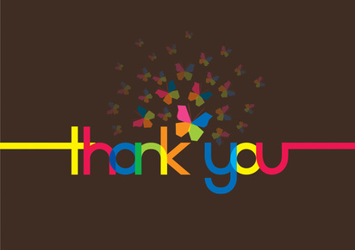
Formal
Thank you very much, I appreciate your ___- Thank you very much, Mr. Anderson, I appreciate your time in helping me review the project.
Thank you so much – Thank you so much, Miss White. I know you worked hard on the project.
Thank you very much – Ms. Wood, thank you very much. I know the clients will appreciate your dedication.
I’m so thankful for ___ – Dr. Benson, I’m so thankful that you had time to see me today. I will try to follow your advice.
I wish to thank you for ___ – Dear T&T, I wish to thank you for your continued business throughout the past ten years.
I want to thank you for___ – Professor Stevens, I want to thank you for explaining that algebra problem to me. I understand it much better now.
I need to thank you for ___ – To the Copp’s Corporation, I need to thank you for your donation to our company picnic. It was extremely generous of you.
***
Informal
Thanks – Thanks for the fun time! We’ll have to meet up again.
Appreciate it – You stayed so late to help out. Appreciate it, Kim.
Cheers – Cheers! All the best, Harry.
4. Responding to thank you’s and appreciation

Formal
You are very welcome – You are very welcome, Mr. Anderson. I am glad the IT presentation was helpful.
You’re quite welcome – You’re quite welcome, Miss Richards. Is there something I can assist you with further?
You’re always welcome – Mr. Thomas, you’re always welcome. Please let me know should you need anything for your trip.
It’s my pleasure – That’s nice of you to say. It’s my pleasure.
The pleasure is all mine – I’m glad it worked out for you. The pleasure is all mine.
That’s the least I could do – You’ve helped us so much. That’s the least I could do.
***
Informal
Sure – Sure. You’re the one that did a great job.
Sure thing – Sure thing. It was easier than I thought.
No sweat – No sweat. It’s about time that I help out a little.
No problem – No problem. It’s fine.
Don’t worry about it – Don’t worry about it. Glad it worked for you.
Don’t mention it – Don’t mention it. Thanks.
Don’t even mention it – Don’t even mention it. Call me if you need anything else.
5. Responding to a simple greeting

Formal
Fine, thank you, and you? – Yes, I’m fine, thank you, and you?
***
Informal
Thanks, I’ve been busy – Thanks, Melanie, I’ve been busy.
Thanks for asking… fine, and you? – Doug, thanks for asking… fine, and you?
Hi – how are you? – Hi, Joey, how about you?
Hi – it’s good to see you – Hi, Grandma, its’ good to see you.
Can’t complain, how about yourself? - You know, Missy, can’t complain, how about yourself?
6. Miscellaneous, often-used casual phrases
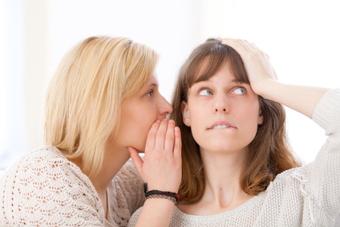
To say something positive or to praise
Good for you – what you say to someone after some good news is shared about something in their own life; it shows you are listening to what they say and that you are sensitive enough to care
That’s a good one – what you say after you hear a good story or joke
That’s a good question – what you say when you are asked a question and you really like the question or you need a little time to think about a possible response; this expression gives you time to pause and tells the listener that you are thinking about a response to the question
That would be great or Sounds good – what you say when you are happy about what someone offers you or explains something to you that you like
***
When you want to know more about something
How do you know? – when someone tells you something that is hard to believe or something that you are very surprised happened, you can ask this simple question to get more information
Really, tell me more about it – this phrase is used to get more juicy information about whatever was discussed
To stress that something is really true, you are in agreement of something, or to offer an explanation
To the best of my knowledge/As far as I know/Frankly speaking/Well, to be perfectly honest – what you say when you are sure of what you are saying and want to clarify what you know or give credit to why you know such and such
You see, let me explain/You see, the thing is that – what you say when you need to explain something
You know what I mean? – what you say to emphasize what you already said or to clarify that the person was listening and understands what you had to say
Can’t argue with that – this expression is used when you agree with what another person says
***
When you can’t believe something or you are surprised
You got me there – this is more of a casual expression than “I don’t understand” or “I don’t know”
You’ve got to be kidding me/You’re kidding me – this is an expression when you hear something that is surprising or catches you off guard
***
Never mind…
Never mind, it’s fine – this expression is used when you turn down an offer from someone to help you with something
Never mind, forget what I just said – this expression is used when you don’t want to talk about something anymore, you want to switch the topic, you changed your mind, you don’t want to offend the listener(s), etc.

